Web development
Structuring your website

Full name:

Form class:

Contents

Task 1 – Identify your website 1
Task 2 - Research 1
Task 3 – Hierarchal design 1
Task 4 - Storyboards 2

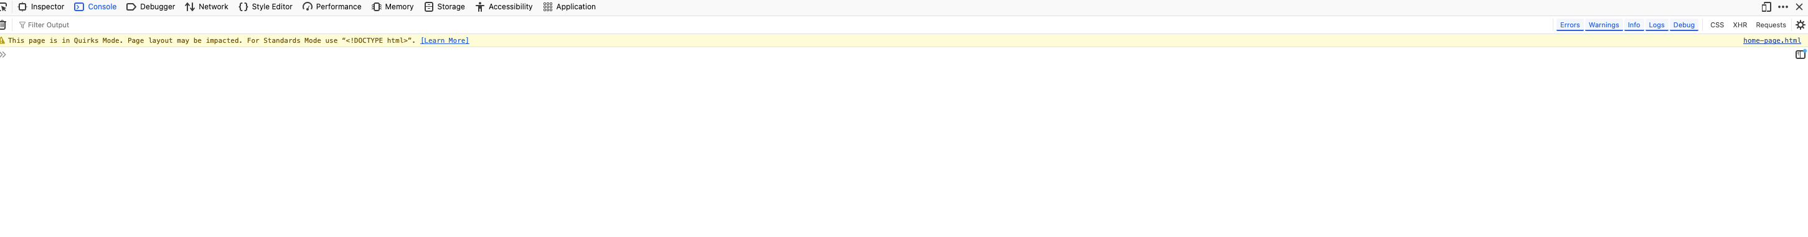
Task 1 – Identify your website
https://developer.mozilla.org/en-US/

What is your website going to be about?
Uk Birds of prey

No | Page Name | Describe what the page will include
1 | Homepage | Homepage will include links to other pages, images and the latest news.
2 | Owls
3 | Falcons
4 | Hawks
5 | Tips | Equipment and reserves to visit
6 | Anomolies | Rare records in the uk

Task 2 - Research

Find some information you can use for your website and add it to this document. Furthermore, find some images and anything else you would like for your website and save it in my documents/pictures

Task 3 – Hierarchal design

Complete your hierarchal design of your website.

Homepage

Falcons

hawks

Owls

Tips

Task 4 - Storyboards

Complete your storyboards for your website. You need a storyboard for each page.

Naviation Bar

Link to a page
Text, images and colours to use:

